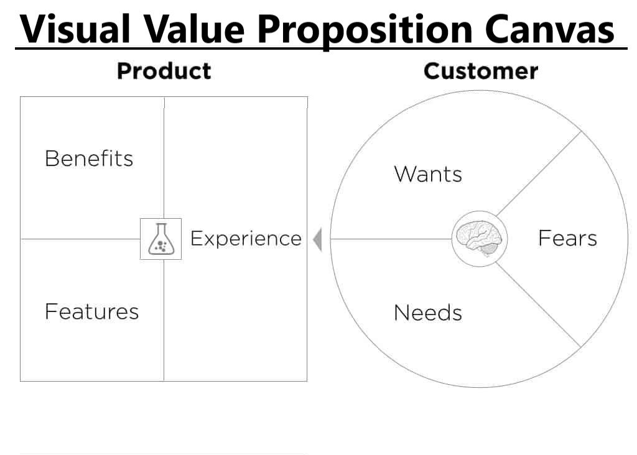

Describe your Features and benefits of your program:

Company - Features
- Product and services alignment
- Unlimited Support – fixed pricing for unlimited calls
- Reliability of systems and connectivity
- Proactive solutions – wholistically
- Ongoing all inclusive support process and delivery
- Controlled costs / predictable expenditures / budgeable success
- Knight in shining armor approach – proactivity and delivery (rescue)

Company - Benefits
Customer success delivery model through our process
Controlled cost due to fixed rate offering
No longer need to be internal IT support for company
Ease of use

Customer experience –
Delightful
PARTNER Not vendor
ROI
Secure
Peace of mind

Understanding your customers and their needs; describe their wants, needs and fears.

Customer – Want’s

Customer – Needs

Customer – Fears

Outputs: How do your features and Benefits address the wants, needs and fears of your customer?

Meaningful sales story:

Elevator pitch:

Initial meeting questions:
- How important is it to you to have the Confidence knowing systems are reliable?
- If there was anything you would change about your current IT support, what would it be ?
- Have you ever had a detailed Technology success plan that showed current and future state? Would that be something you would like to see or have?

